**Project Report Template**

1. INTRODUCTION
   1. Overview

A brief description about your project

* 1. Purpose

The use of this project. What can be achieved using this.

1. PROBLEM DEFINITION & DESIGN THINKING
   1. Empathy map

Paste the empathy map screenshot

* 1. Ideation & brainstorming Map

Paste the Ideation & brainstorming map screenshot.

1. RESULT

Final findings (Output) of the project along with screenshot.

1. ADVANTAGES

List of advantages and disadvantages pf the proposed solution.

1. APPLICATION

The areas where this solution can be applied.

1. CONCLUSION

Conclusion summarizing the entire work and findings.

1. FUTURE SCOPE

Enhancements that can be made in this future.

1. APPENDIX

A. Source Code

Attach the code for the solution built.

**Measuring the pulse of prosperity: an index of economic freedom analysis**

# 1. INTRODUCTION

## Economic freedom index

## The index of economic freedom is a guide published every year by the Heritage Foundation.

## The index of economic freedom has been a source of valuable information that has been used people around the world for 29 years.

## 1.1 OVERVIEW

## Economic freedom index is a measure of economic freedom and is usually calculated with a country as the upper boundary. Eg. India’s economic freedom score is 52.9

## It is calculated based on 12 quantitative and qualitative factors and these factors are grouped under 4 main groups or pillars

## Rule of law

## Government size

## Regulatory efficiency

## Open markets

## 1.2 PURPOSE

* The challenges that the freedom index has set us in analysing are quite interesting and we are excited to see how much our perspective changes over time.

# 2. PROBLEM DEFINITION & DESIGN THINKING

## EMPATHY MAP

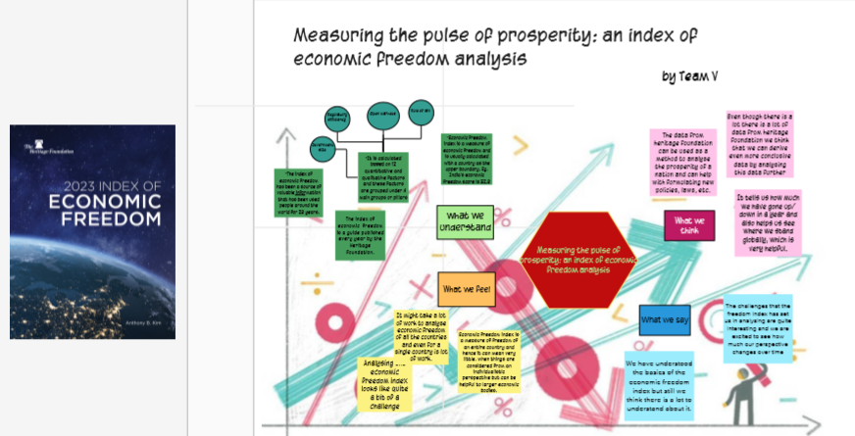

2.2 IDEATION & BRAINSTORMING MAP

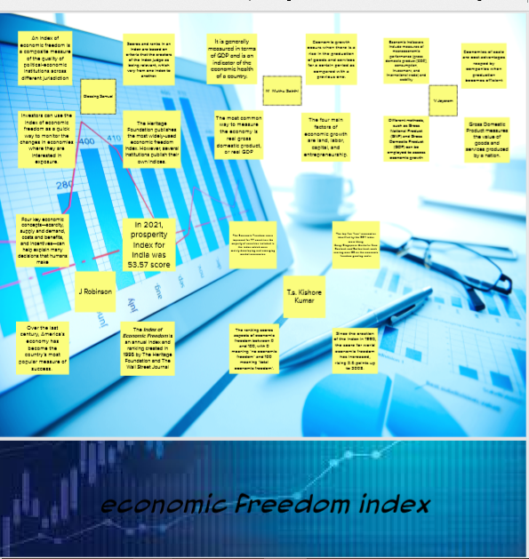

## 3. RESULT

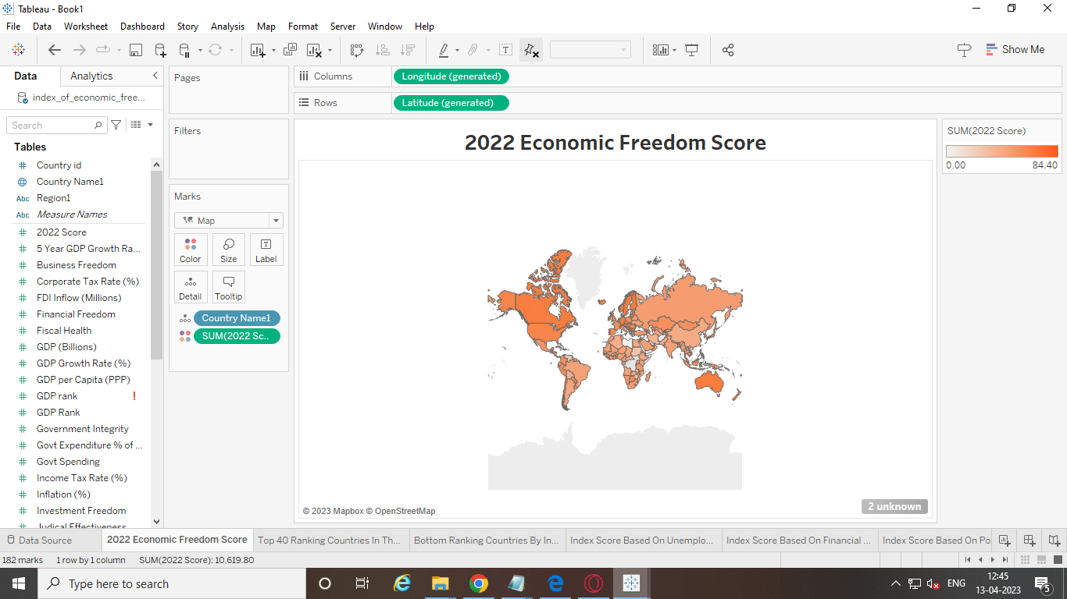

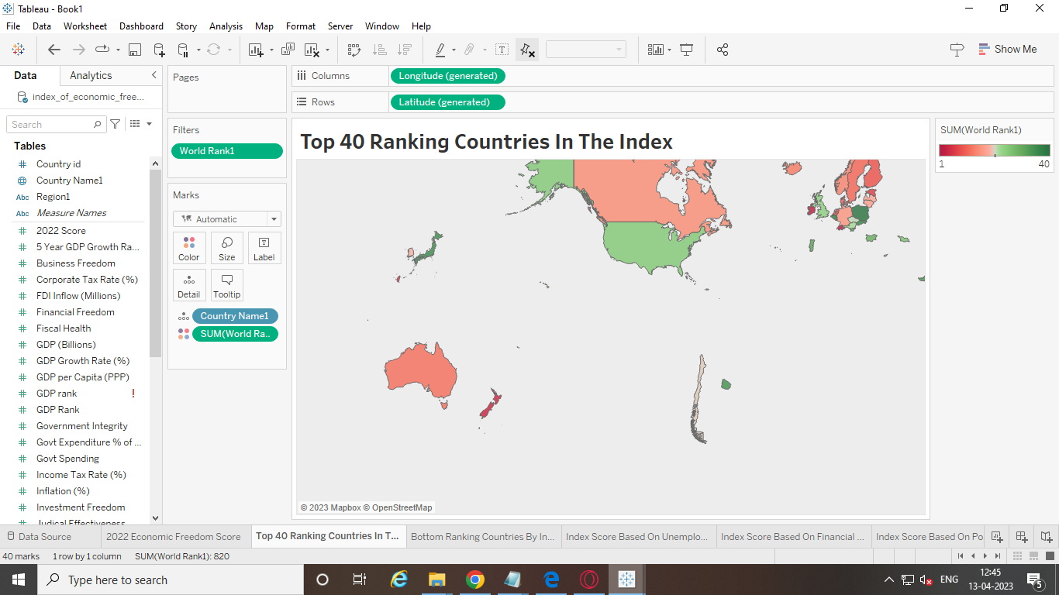

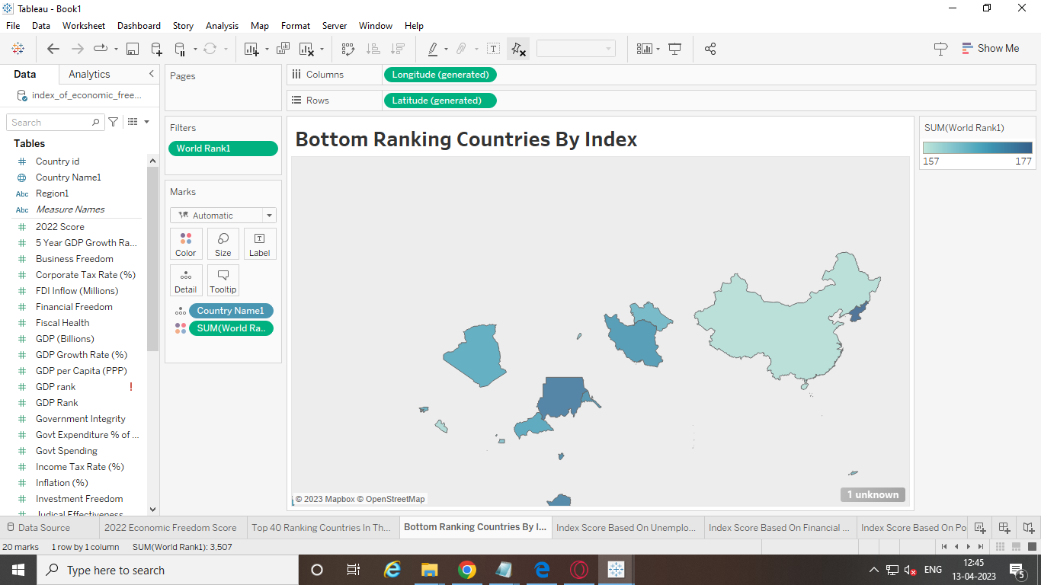

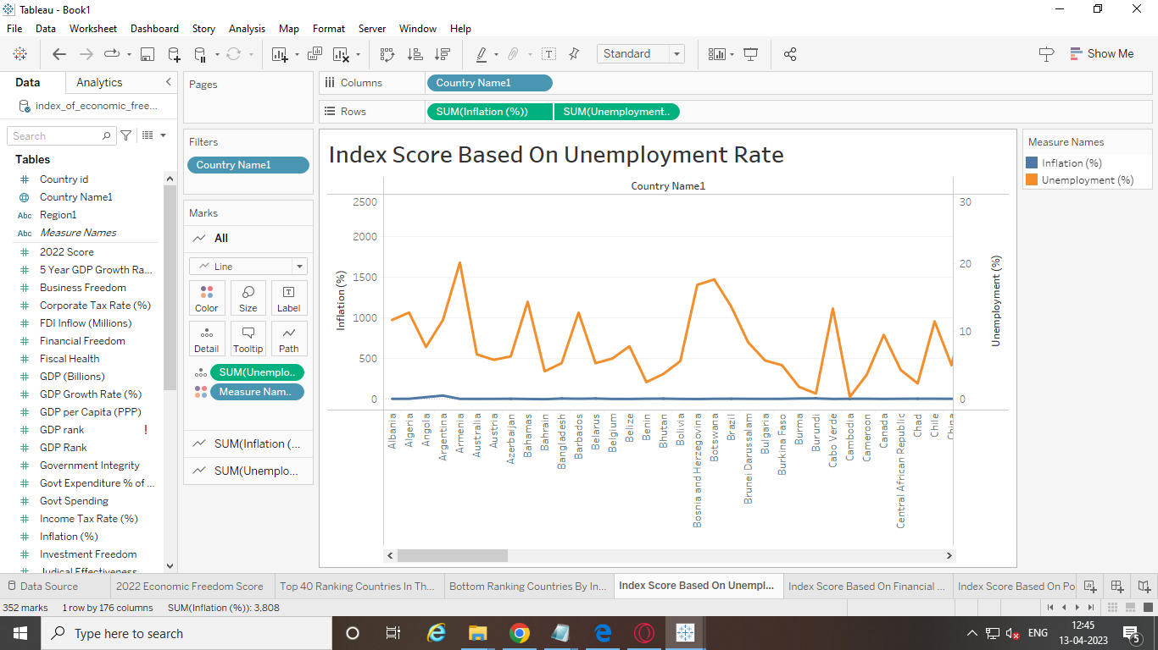

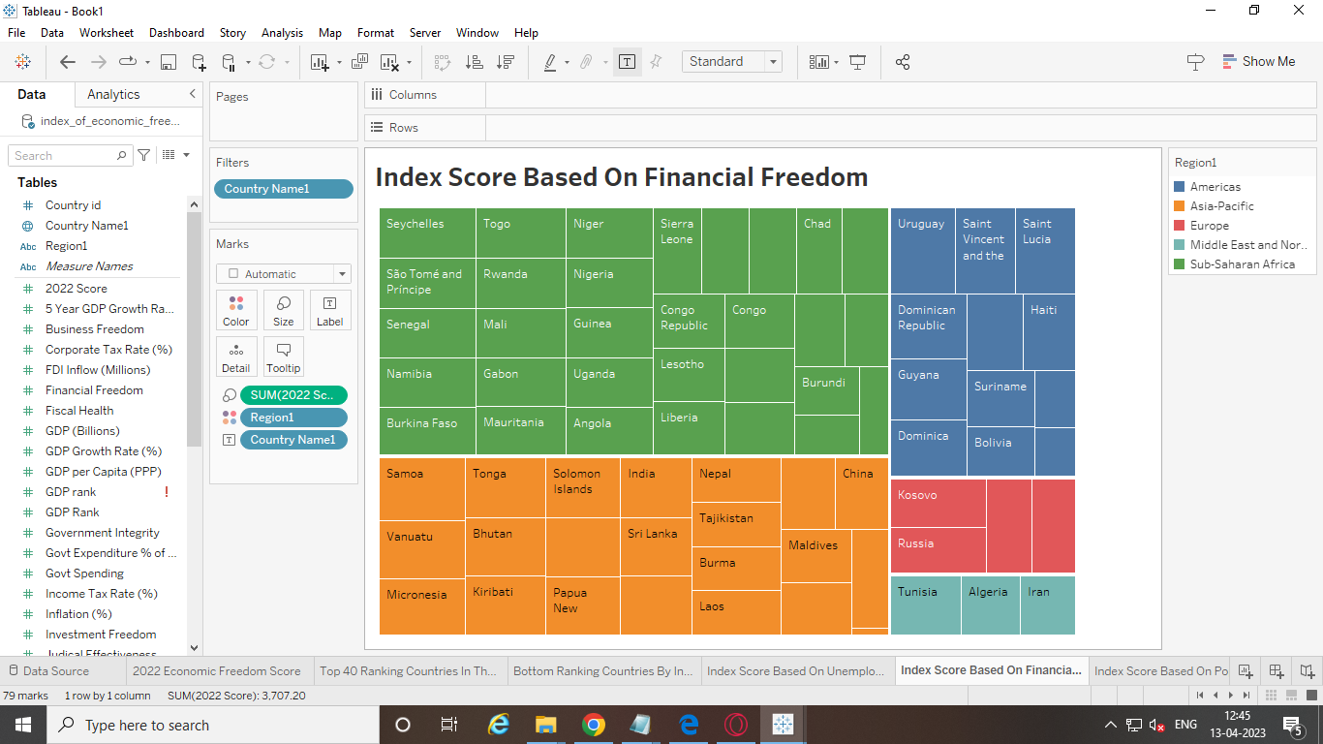

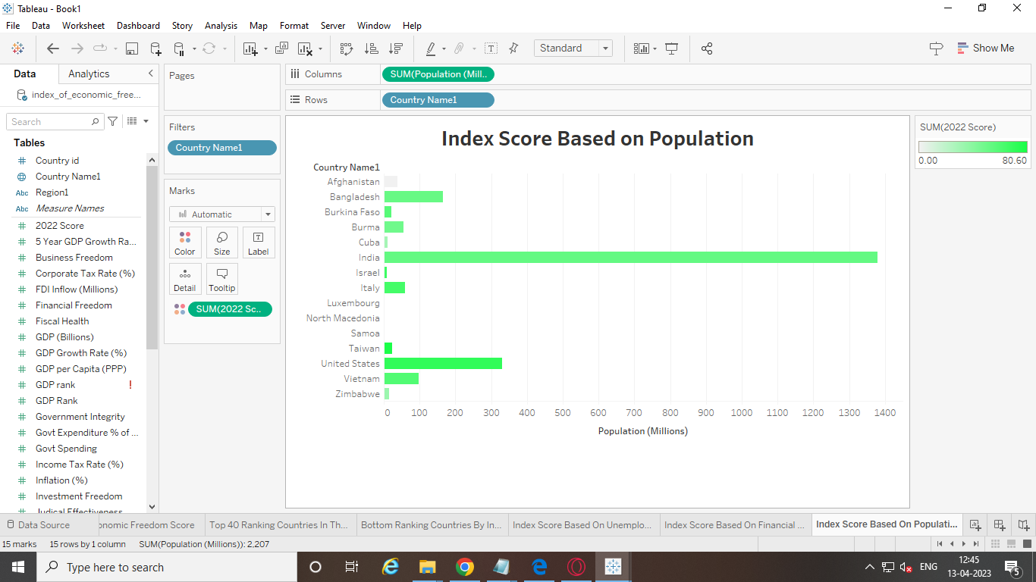

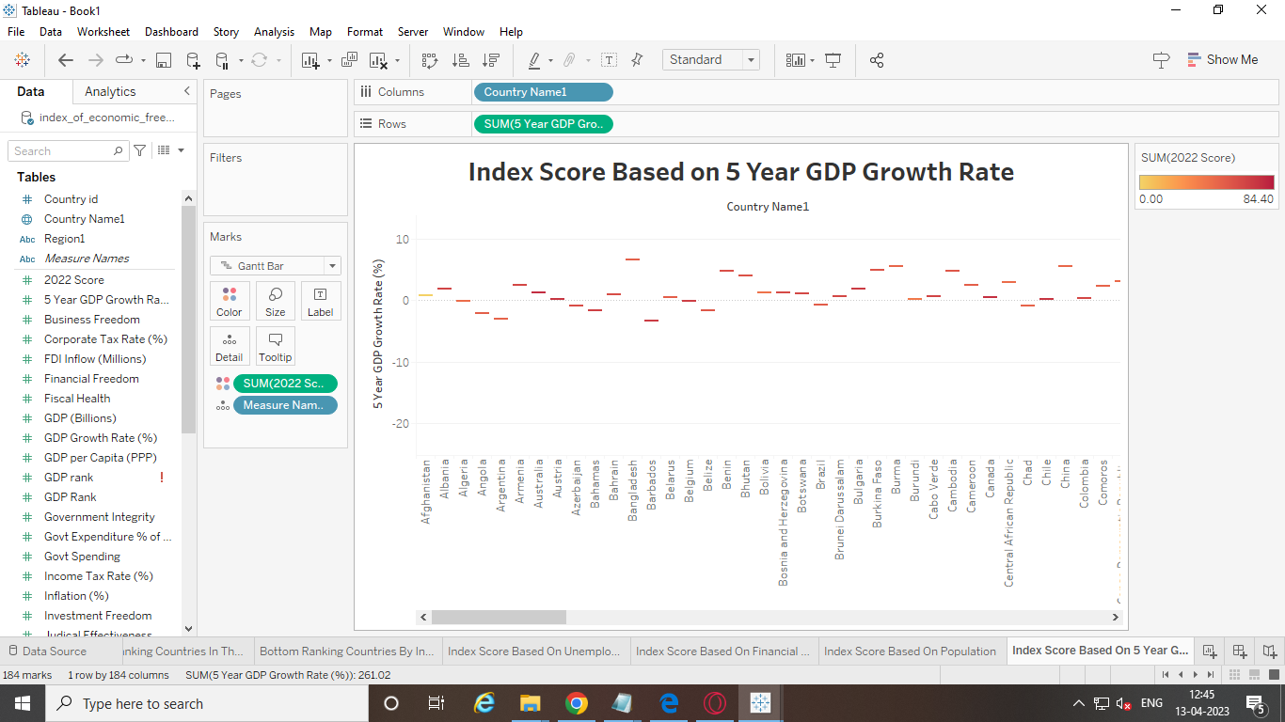

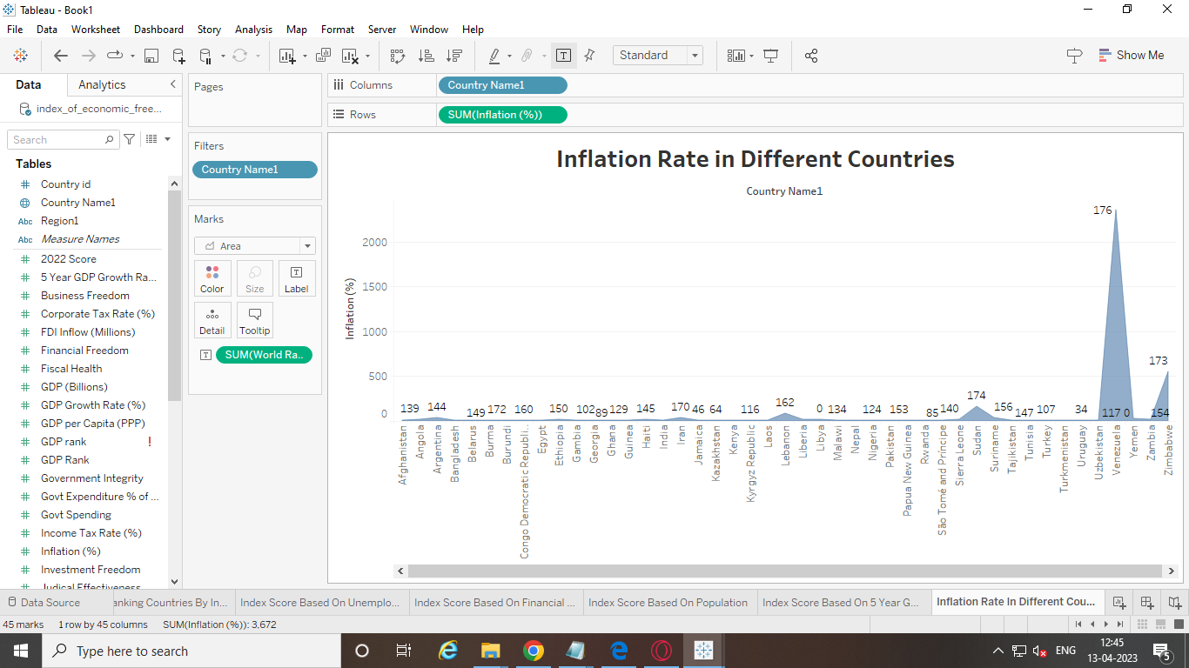

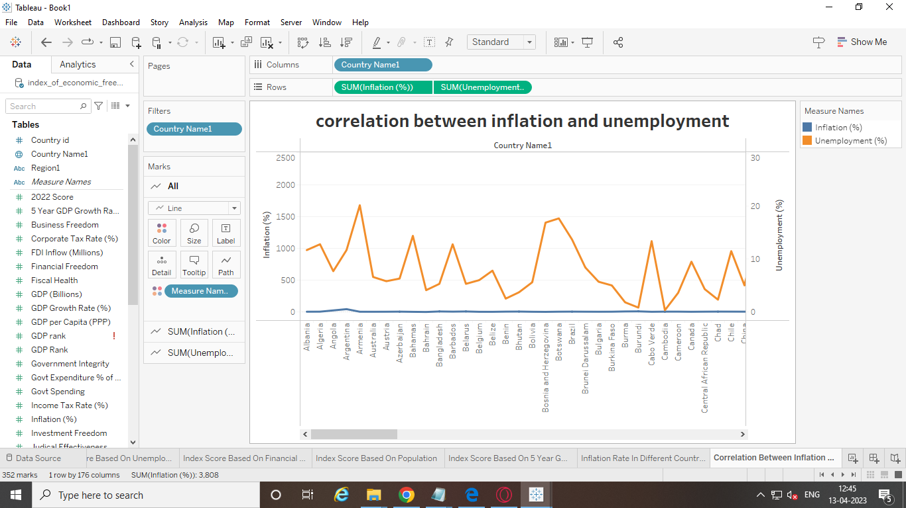

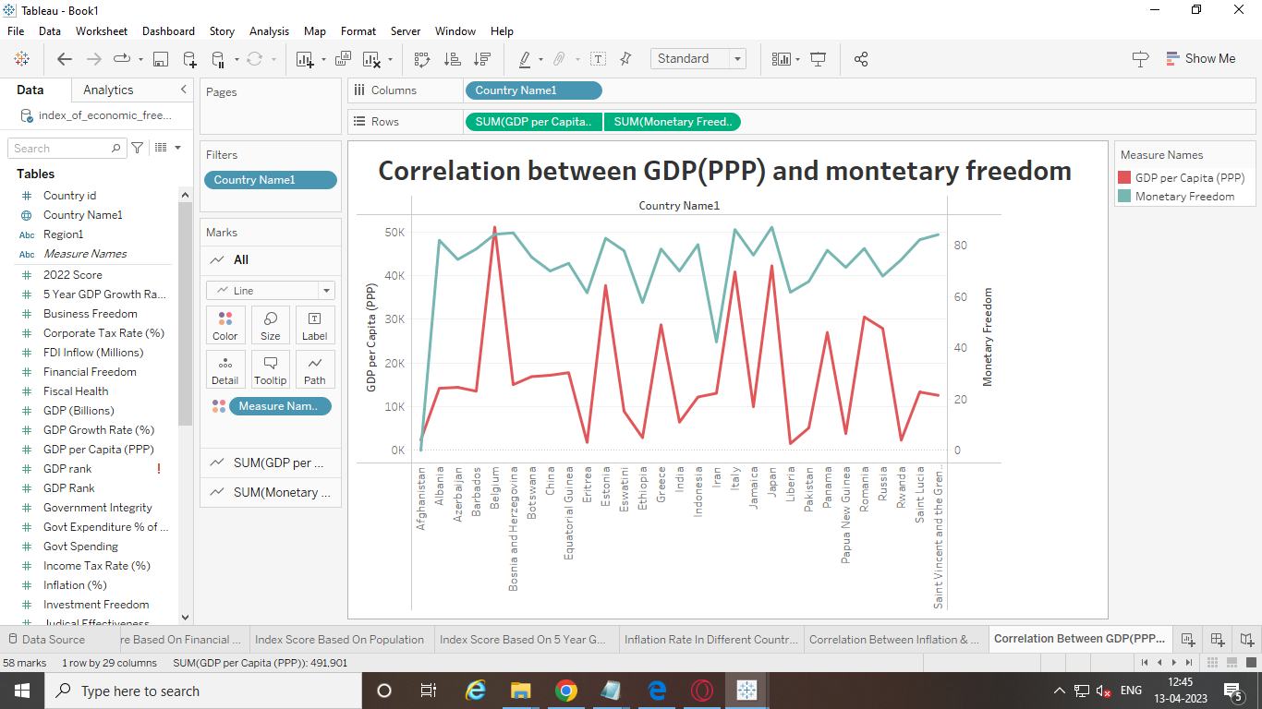

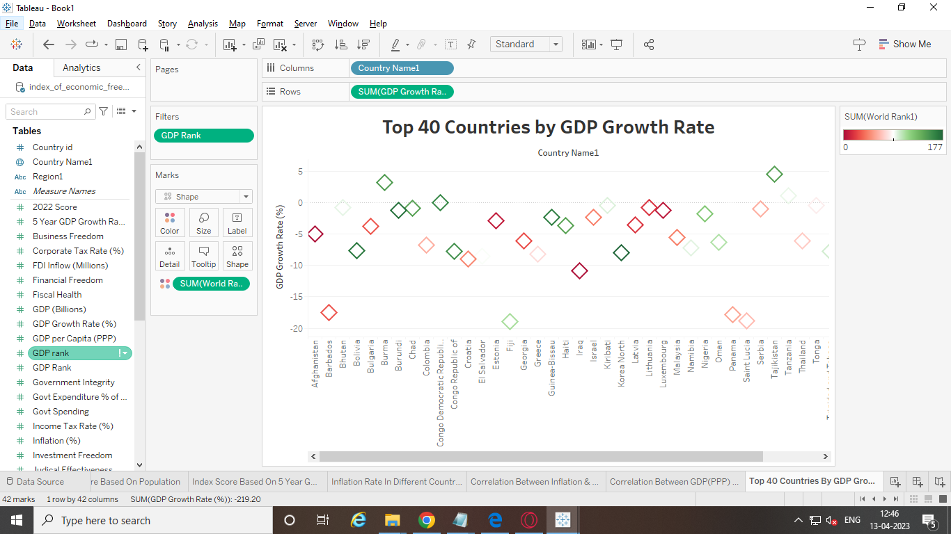

## 4. ADVANTAGES & DISADVANTAGES

***ADVANTAGES:***

1. Helps identify the strengths and weaknesses of a country's economic policies: Analyzing the economic freedom index helps identify the areas where a country is performing well and the areas where it needs to improve. This information can be used by policymakers to develop better economic policies that promote growth and prosperity.
2. Provides a benchmark for comparison: The economic freedom index provides a benchmark for comparison between different countries. This allows policymakers to see how their country is performing relative to others and can provide insights into what policies are working well in other countries.
3. Encourages competition and innovation: A higher economic freedom index encourages competition and innovation as businesses are free to operate without excessive government intervention. This leads to more efficient markets and better outcomes for consumers.
4. Attracts foreign investment: A high economic freedom index can attract foreign investment as investors are more likely to invest in countries with favorable economic policies. This can lead to increased job creation and economic growth.
5. Promotes individual freedom: A high economic freedom index promotes individual freedom as individuals are free to pursue their own economic interests without excessive government intervention. This leads to greater personal autonomy and a more vibrant civil society.

***DISADVANTAGES:***

1. Limited scope: The economic freedom index does not consider social factors such as income inequality, poverty, and access to education and healthcare. Therefore, it may not provide a comprehensive picture of a country's economic and social well-being.
2. Biased towards free-market policies: The economic freedom index is based on a free-market ideology, which may not be suitable for all countries and may lead to policies that are not in the best interests of all citizens.
3. Lack of transparency: The methodology used to calculate the economic freedom index is not always transparent, which can lead to questions about the accuracy and validity of the results.
4. Ignores external factors: The economic freedom index does not take into account external factors such as global economic conditions, which can have a significant impact on a country's economy.
5. Can be manipulated: The economic freedom index can be manipulated by governments to make their economic policies appear more favorable than they actually are. This can lead to inaccurate assessments of a country's economic performance

## 5. APPLICATIONS

* Investment decisions: Investors may use the economic freedom index to assess the business environment and potential risks in a country before making investment decisions.
* Policy-making: Governments may use the economic freedom index as a benchmark to evaluate their economic policies and make necessary changes to improve their ranking.
* International trade: The economic freedom index can be used as a tool for countries to negotiate trade agreements and assess the economic policies of potential trading partners.
* Academic research: Scholars may use the economic freedom index as a data source to conduct research on the relationship between economic freedom and economic growth, income inequality, and other economic and social factors.
* Advocacy: Advocacy groups may use the economic freedom index to promote policies that align with their ideology and to advocate for change in countries with low rankings.

## 6. CONCLUSION

The economic freedom index provides a measure of the level of economic freedom in a country, which can be used to assess the business environment, potential risks, and economic policies. It can also be used as a tool for international trade negotiations, academic research, and advocacy. A higher ranking on the index indicates a greater level of economic freedom, which is generally associated with higher levels of economic growth and prosperity.

## 7.FUTURE SCOPE

The future development of the economic freedom index is likely to focus on refining the methodology used to calculate the index and expanding its coverage to include more countries. This may involve incorporating new data sources, such as satellite imagery and social media analytics, and developing more sophisticated algorithms to analyze the data.

In addition, there may be a greater emphasis on measuring specific aspects of economic freedom, such as property rights, regulatory efficiency, and labor market flexibility. This could help policymakers and businesses identify areas where reforms are needed to improve the business environment and promote economic growth.

Another potential development is the use of the economic freedom index as a tool for assessing the impact of global trends, such as the rise of digital technologies and the growing importance of environmental sustainability. This could involve developing new indicators that capture the economic implications of these trends, such as the impact on innovation, productivity, and resource efficiency.

Overall, the economic freedom index is likely to continue to evolve and adapt to changing economic and political circumstances, providing a valuable tool for policymakers, businesses, and researchers around the world.

## 8. APPENDIX

**A. SOURCE CODE**